**Project report**

**Course Title – Computer Programming**

**Project Topic:- ATM system**

**Group Members:-**

|  |  |
| --- | --- |
| **Name : MUHAMMAD ISAM** | **Enrollment : 02-134221-045** |
| **Name : ZOBIA GUL** | **Enrollment : 02-134221-064** |
| **Name : SOFIA HAIDER** | **Enrollment : 02-134221-090** |

**Class:-**

BSCS – 1 – B

**Submitted to**

**LAB INSTRUCTOR: Ms. Tooba Zahed**

**COURSE INSTRUCTOR: Ms. Azeema Sadia**

Table of Contents

1. Objective 3

2. Scope of Project 3

3. Methodology 3

4. Block Diagram/Flow Chart 4

**5. Concepts used in project …………………………………………………………… 4**

6. Working of Project 5-6

**7. Source Code……...……………………………………………..6-17**

8. Screenshots of Project 17-22

9. Conclusion 23

**Objective:**

Banking ATM is a simple and basic level project for learning purpose in C++, It is basically **a desktop application which is developed using visual studio. ATM System** is used to access their bank accounts in order to make cash withdrawals. Whenever the user need to make cash withdraws, they can enter their PIN number (personal identification number) and it will display the amount to be withdrawn .Once their withdrawn was successful, the amount will be debited in their account.

The ATM gives services one customer at a time. Customer will be required to enter ATM Card number, personal identification number (PIN) – both of which will be sent to the database for validation as part of each transaction. The customer will then be able to perform one or more required option. Also customer must be able to make a balance inquiry of any account linked to the card. A transaction could fail if the customer enter wrong account number or PIN.

**Scope of project:-**

**ATM**are [Automated Teller Machines](https://www.geeksforgeeks.org/use-case-diagram-for-bank-atm-system/) that are used to multiple financial transactions for multiple customers. ATMs can be used for

1. Balance inquiry
2. Withdraw
3. Deposit
4. Pin change
5. Utility Bill Payment
6. Fund Transfer.

They are very convenient and easy to use, it allows customers to perform quick self-service transactions as well. The scope of ATM system is very high as it is used at almost every part of the world.

**Methodology:-**

The Methodology of ATM system is simple, it is to provide a safe and secure way of transaction of money through a place for customers. The methods to use ATM machine is short and simple, The customer needs to enter the account number and PIN, if the Account and Pin matches then the system proceeds for further question and asks the customers to choose the desired choice. If any logical error does not occur the required task chosen by the customer is successfully completed.

Any customer with an account can use the system.

**Flowchart:-**

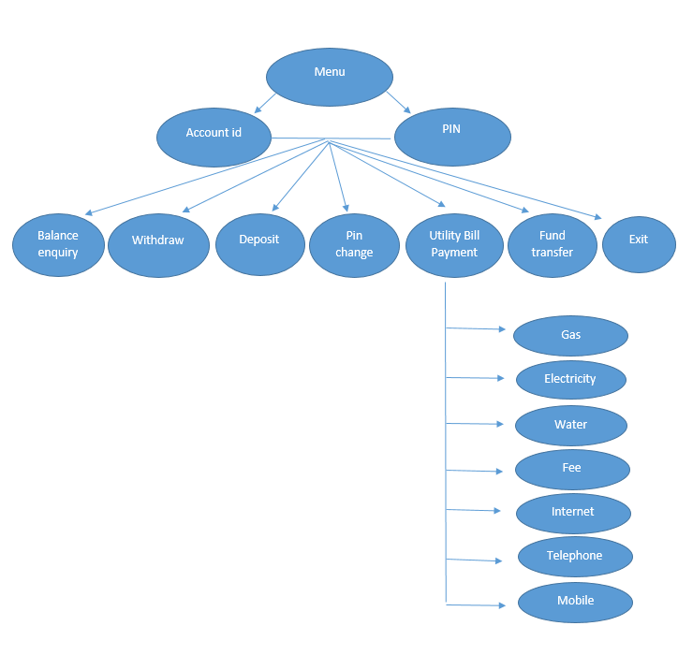

**Concept used in project:-**

The following concept is used in our project

1. Structure
2. Array
3. String
4. Function
5. If else statement
6. Switch statement
7. File handling

**Working of project:-**

The ATM system takes input in the form of account id and PIN, if the correct correct id and PIN is input, the system proceeds and asks the user to choose one of the following category which performs a certain task. These are the following 7 categories:-

1. **Balance Inquiry:-**

It displays the total amount of balance present in the customer’s account

1. **Withdraw:-**

The system first ask the customer to enter the amount to withdraw then checks if the amount is less than total balance, if yes then it shows successful otherwise it displays not enough balance

1. **Deposit:-**

The customer is asked to enter the amount which is required to be deposited, which is then added with the total balance of the customer’s account.

1. **Pin Change:-**

The customer needs to enter the correct PIN which is saved in the system through a text file, if the PIN matches only then the customer is asked to enter the New PIN twice which needs to be same 4 digit number, if the digits are same twice the New pin is changed

1. **Utility Bill Payment:-**

It is basically used to pay through your account. The customer is required to select an option, there are 8 options which are given as below

1. Gas
2. Electricity
3. Water
4. Fee
5. Internet
6. Telephone
7. Mobile
8. Exit

After the option is selected, by the process of method overloading the command goes to another function. However if the customer select 8, the command directly goes to the main menu

**Function:-**

the costumer is required to input the number in which they want to pay the payable amount. Which is saved in a text file, the system checks whether the entered account number is same or different. If it is same the system ask whether they want to pay or cancel. And it is deducted from the costumer’s account.

1. **Fund transfer:-**

In order to transfer fund into another account, the user first needs to enter the account id of the other account, the system then checks with the loop function if the entered account is registered in ATM system or not. If the account is registered, the customer is then asked the amount needed to transfer, which is then checked if the balance is greater than the amount. If not then the entered amount is added in the other account, and subtracted from the customer’s account. The message of fund transfer successful is shown.

1. **Exit:-**

The program ends as the customer enters exit, the final account balance is stored in the text files using for loop.

**Source code:-**

#include<iostream>

#include<string>

#include<fstream>

#include<stdlib.h>

using namespace std;

struct account

{

string name;

int pin = 0;

long int number = 0;

long int balance = 0;

}acc[3];

fstream client, myfile, file, utb;

void bill(int a)

{

int choice, rbill[10], verify = 0;

long int amount, finalbalance;

long long rid[10], consumernum;

utb.open("utilitybills.txt", ios::in);

for (int i = 0; i < 10; i++)

{

utb >> rid[i];

utb >> rbill[i];

}

cin >> consumernum;

for (int i = 0; i < 10; i++)

{

if (consumernum == rid[i])

{

if (rbill[i] > 0)

{

cout << "\tAmount Payable: RS" << rbill[i] << endl;

cout << "\tPress 1 to Pay\n\tPress 2 to Cancel\n";

cin >> choice;

if (choice == 1)

{

amount = rbill[i];

if (amount > acc[a].balance)

{

cout << "\tError! Your transaction amount exceeds your bank balance!\n";

break;

}

else

{

finalbalance = acc[a].balance - amount;

acc[a].balance = finalbalance;

cout << "\t * BILL PAYMENT SUCCESSFUL * " << endl << endl;

cout << "\tYou have paid the bill of RS: " << amount << endl << endl;

rbill[i] = 0;

utb.close();

utb.open("utilitybills.txt", ios::out);

for (int j = 0; j < 10; j++)

{

utb << rid[j] << endl;

utb << rbill[j] << endl;

}

utb.close();

break;

}

}

if (choice == 2)

{

break;

}

}

else

{

cout << "\tThere is not outstanding bill to be paid against this Account ID.\n";

break;

}

}

else if (consumernum != rid[i])

{

verify = verify + 1;

}

if (verify == 10)

{

cout << "\tInvalid Bill ID Entered!\n";

break;

}

}

}

void fundtransfer(int a)

{

long int accid, casht;

int check = 0;

E:

cout << "\tEnter the Account ID to transfer cash to: ";

cin >> accid;

for (int j = 0; j < 3; j++)

{

if (accid == acc[j].number)

{

if (acc[j].number == acc[a].number)

{

cout << "\tError! You can't transfer money to your own account!\n";

goto E;

}

cout << "\tEnter the amount you want to transfer to " << acc[j].name << " Rs: ";

cin >> casht;

if (casht > acc[a].balance)

{

cout << "\tError! Your transaction amount exceeds your bank balance!\n";

}

else

{

acc[a].balance = acc[a].balance - casht;

acc[j].balance = acc[j].balance + casht;

cout << "\t * FUNDTRANSFER SUCCESSFUL *" << endl << endl;

cout << "\tCash Rs " << casht << " transferred to " << acc[j].name << "'s account!\n\n";

}

break;

}

else if (accid != acc[j].number)

{

check = check + 1;

}

if (check == 3)

{

cout << "\tInvalid Account ID! It does not exists!\n";

goto E;

}

}

}

void balance_inquiry(int a)

{

cout << "\n\tThe total amount of balance in your account is RS: " << acc[a].balance << endl << endl;

}

void withdraw(int a)

{

long int withdraw, TOTAL;

cout << "\tEnter the amount of cash you want to withdraw Rs: ";

cin >> withdraw;

if (acc[a].balance >= withdraw)

{

TOTAL = acc[a].balance - withdraw;

acc[a].balance = TOTAL;

cout << "\t * WITHDRAW SUCCESSFUL *" << endl << endl;

cout << "\tYou have withdrawn RS: " << withdraw << endl << endl;

}

else

{

cout << "\tNot Enough Money In Your Account!\n";

cout << endl;

}

}

void deposit(int a)

{

long int dep, finalbalance;

cout << endl << "\tEnter the amount of cash you want to deposit RS: ";

cin >> dep;

finalbalance = acc[a].balance + dep;

acc[a].balance = finalbalance;

cout << "\t * DEPOSIT SUCCESSFUL * " << endl << endl;

cout << "\tYou have deposited RS: " << dep << endl << endl;

}

void pinchange(int a)

{

int pin, newpin, renewpin;

F:

cout << "\tEnter current PIN : ";

fstream file;

file.open("pin.txt", ios::out);

cin >> pin;

if (pin == acc[a].pin)

{

cout << "\tEnter new PIN : ";

cin >> newpin;

if (newpin >= 1000 && newpin <= 9999)

{

cout << "\tAgain enter new PIN : ";

cin >> renewpin;

if (newpin == renewpin)

{

acc[a].pin = renewpin;

cout << "\t * PIN CHANGE SUCCESSFUL * " << endl << endl;

cout << "\tYour new PIN is : " << acc[a].pin << endl << endl;

file << acc[0].pin << endl;

file << acc[1].pin << endl;

file << acc[2].pin << endl;

file.close();

}

else

{

cout << "\tThe PINs do not match" << endl;

goto F;

}

}

else

{

cout << "\tYou failed to enter a 4 digit pin!\n";

}

}

else

{

cout << "\tWRONG PIN!";

goto F;

}

}

void utilitybillpayment(int a)

{

int option = 0;

cout << endl << " " << acc[a].name << " please select an option to proceed.\n";

cout << " * MENU * " << endl;

cout << "\t1. Gas\t 2. Electricity\n\t3. Water\t 4. Fee\n\t5. Internet\t 6. Telephone\n\t7. Mobile Phone\t 8. Exit\n";

cin >> option;

switch (option)

{

case 1:

{

cout << "\tGAS BILL" << endl;

cout << "\tEnter your Consumer Number: ";

bill(a);

break;

}

case 2:

{

cout << "\tELECTRICITY BILL" << endl;

cout << "\tEnter your Consumer Number: ";

bill(a);

break;

}

case 3:

{

cout << "\tWATER BILL" << endl;

cout << "\tEnter your Consumer Number: ";

bill(a);

break;

}

case 4:

{

cout << "\tFEE BILL" << endl;

cout << "\tEnter your Consumer Number: ";

bill(a);

break;

}

case 5:

{

cout << "\tINTERNET BILL" << endl;

cout << "\tEnter your Consumer Number: ";

bill(a);

break;

}

case 6:

{

cout << "\tTELEPHONE BILL" << endl;

cout << "\tEnter your Telephone Number: ";

bill(a);

break;

}

case 7:

{

cout << "\tMobile Bill" << endl;

cout << "\tEnter your Mobile Number: ";

bill(a);

break;

}

case 8:

cout << "\tReturning to Menu!\n";

break;

default:

{

cout << "\tInvalid Option!" << endl;

break;

}

}

}

int main()

{

acc[0].name = "Sofia Haider";

acc[0].number = 57892122;

acc[1].name = "Muhammad Isam";

acc[1].number = 44229982;

acc[2].name = "Zobia Gul";

acc[2].number = 66945678;

myfile.open("balance.txt", ios::in);

myfile >> acc[0].balance;

myfile >> acc[1].balance;

myfile >> acc[2].balance;

myfile.close();

file.open("pin.txt", ios::in);

file >> acc[0].pin;

file >> acc[1].pin;

file >> acc[2].pin;

file.close();

int accnum, accpin, choice;

system("COLOR 70");

A:

system("cls");

AB:

cout << "\n\tWelcome to Bahria's ATM Machine\n";

cout << "\tPlease enter your Account ID: ";

cin >> accnum;

int check = 0;

for (int i = 0; i < 3; i++)

{

if (accnum == acc[i].number)

{

B:

cout << "\tPlease enter your PIN: ";

cin >> accpin;

if (accpin == acc[i].pin)

{

int a = i;

C:

cout << endl << " " << acc[i].name << " please select an option to proceed.\n";

cout << " * MENU * " << endl;

cout << " 1. Balance Inquiry\t 2. Withdraw\n 3. Deposit\t 4. Pin Change\n 5. Utility Bill Payment\t 6. Fund Transfer\n 7. Exit\t\n";

cin >> choice;

switch (choice)

{

case 1:

{

balance_inquiry(a);

goto C;

}

case 2:

{

withdraw(a);

goto C;

}

case 3:

{

deposit(a);

goto C;

}

case 4:

{

pinchange(a);

goto C;

}

case 5:

{

utilitybillpayment(a);

goto C;

}

case 6:

{

fundtransfer(a);

goto C;

}

case 7:

{

cout << "\tLogging out!\n\tLogging out!\n\tLogging out!\n\tLogging out!\n";

myfile.open("balance.txt", ios::out);

myfile << acc[0].balance << endl;

myfile << acc[1].balance << endl;

myfile << acc[2].balance << endl;

myfile.close();

client.open("client.txt", ios::out);

for (int i = 0; i < 3; i++)

{

client << "Account name: " << acc[i].name << endl;

client << "Account number: " << acc[i].number << endl;

client << "Account pin: " << acc[i].pin << endl;

client << "Account balance: Rs " << acc[i].balance << endl << endl;

}

client.close();

goto A;

}

default:

cout << "\tInvalid option entered!\n";

goto C;

}

}

else

{

cout << "\tWRONG PIN!\n";

goto B;

}

break;

}

else

{

check = check + 1;

}

if (check == 3)

{

cout << "\tInvalid account ID!\n";

goto AB;

}

}

system("pause");

}**Screenshot:-**

1. Customer has entered correct account number and PIN, and the system is showing the options for the customer to choose.

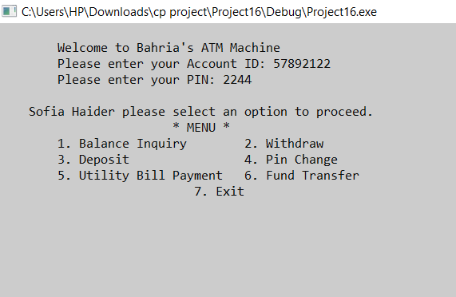

1. The customer checks the total amount of balance , then withdraws 50000 amount, and rechecks the total amount of balance.

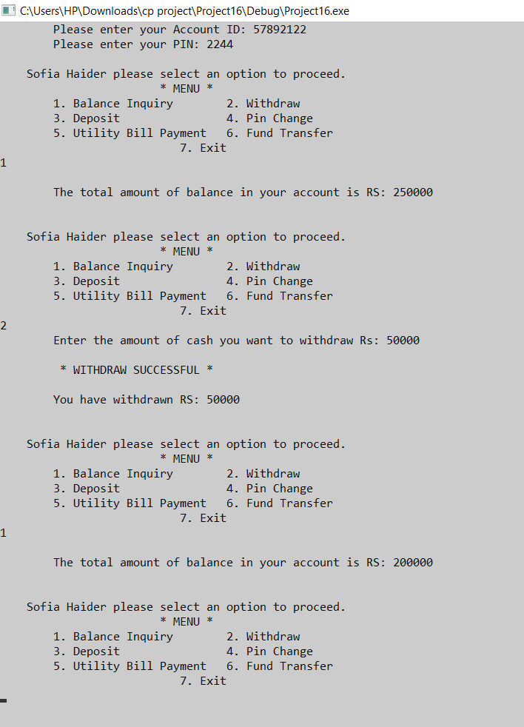

1. The customer deposit 50000 in the account, after deposit is successful the customer checks the total balance in the account

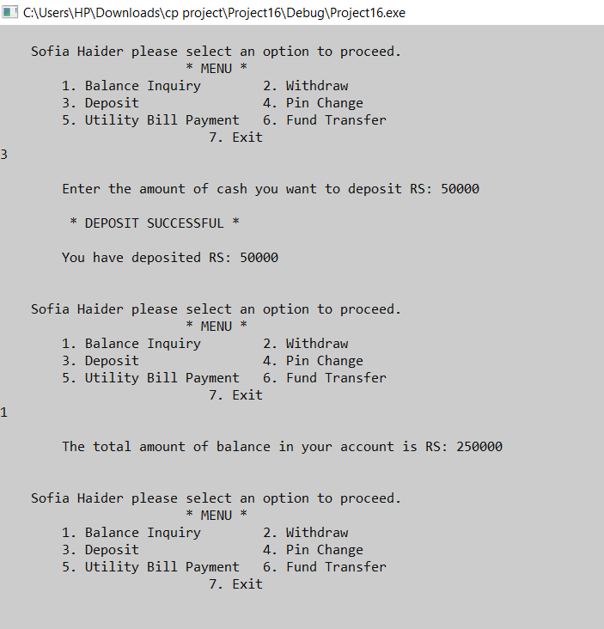

1. The customer fails to enter the correct PIN, the system asks the customer again, the entered PIN does not match with the reentered PIN so the PIN is not changed, the customer then enter 5 number digit due which the command goes back to menu. The customer then again select PIN exchange and the process is successful

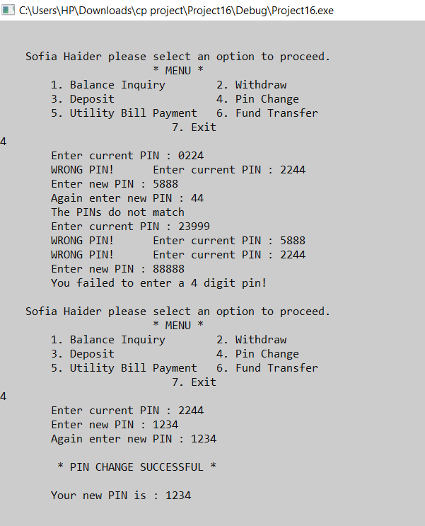

1. The customer pays the utility bill through the system, as the customer chooses gas bill option, the payable amount is displayed on the screen and the customer is asked if they want to pay or want to cancel. If the option of payment is choose the total amount is deducted from the total balance

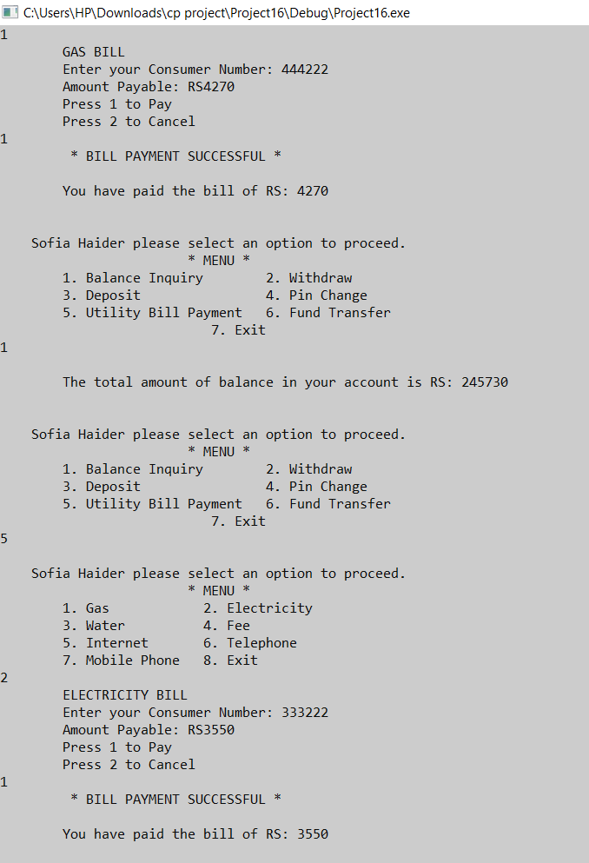

1. To the transfer the cash from one account to another the customer first asks the amount of cash to be transferred , then asks for the account id of the account the cash needs to be transferred and lastly deducts the amount from the customer’s account.

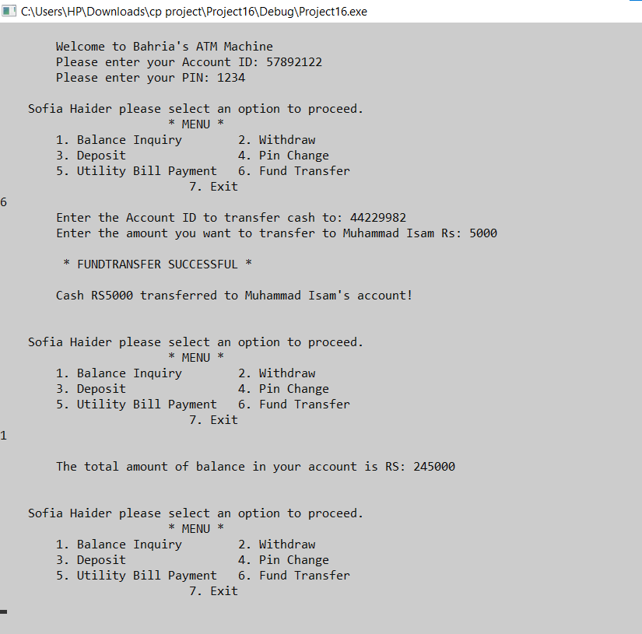

**Conclusion:-**

ATM system has helped everyone on a very high scale, this program have been created by many different concepts. The use of this program is very simple, and can be understood easily by the customer. It can be utilized in many different ways which are given above. Many required task can be performed using ATM system. It provides a safe and human error free machine